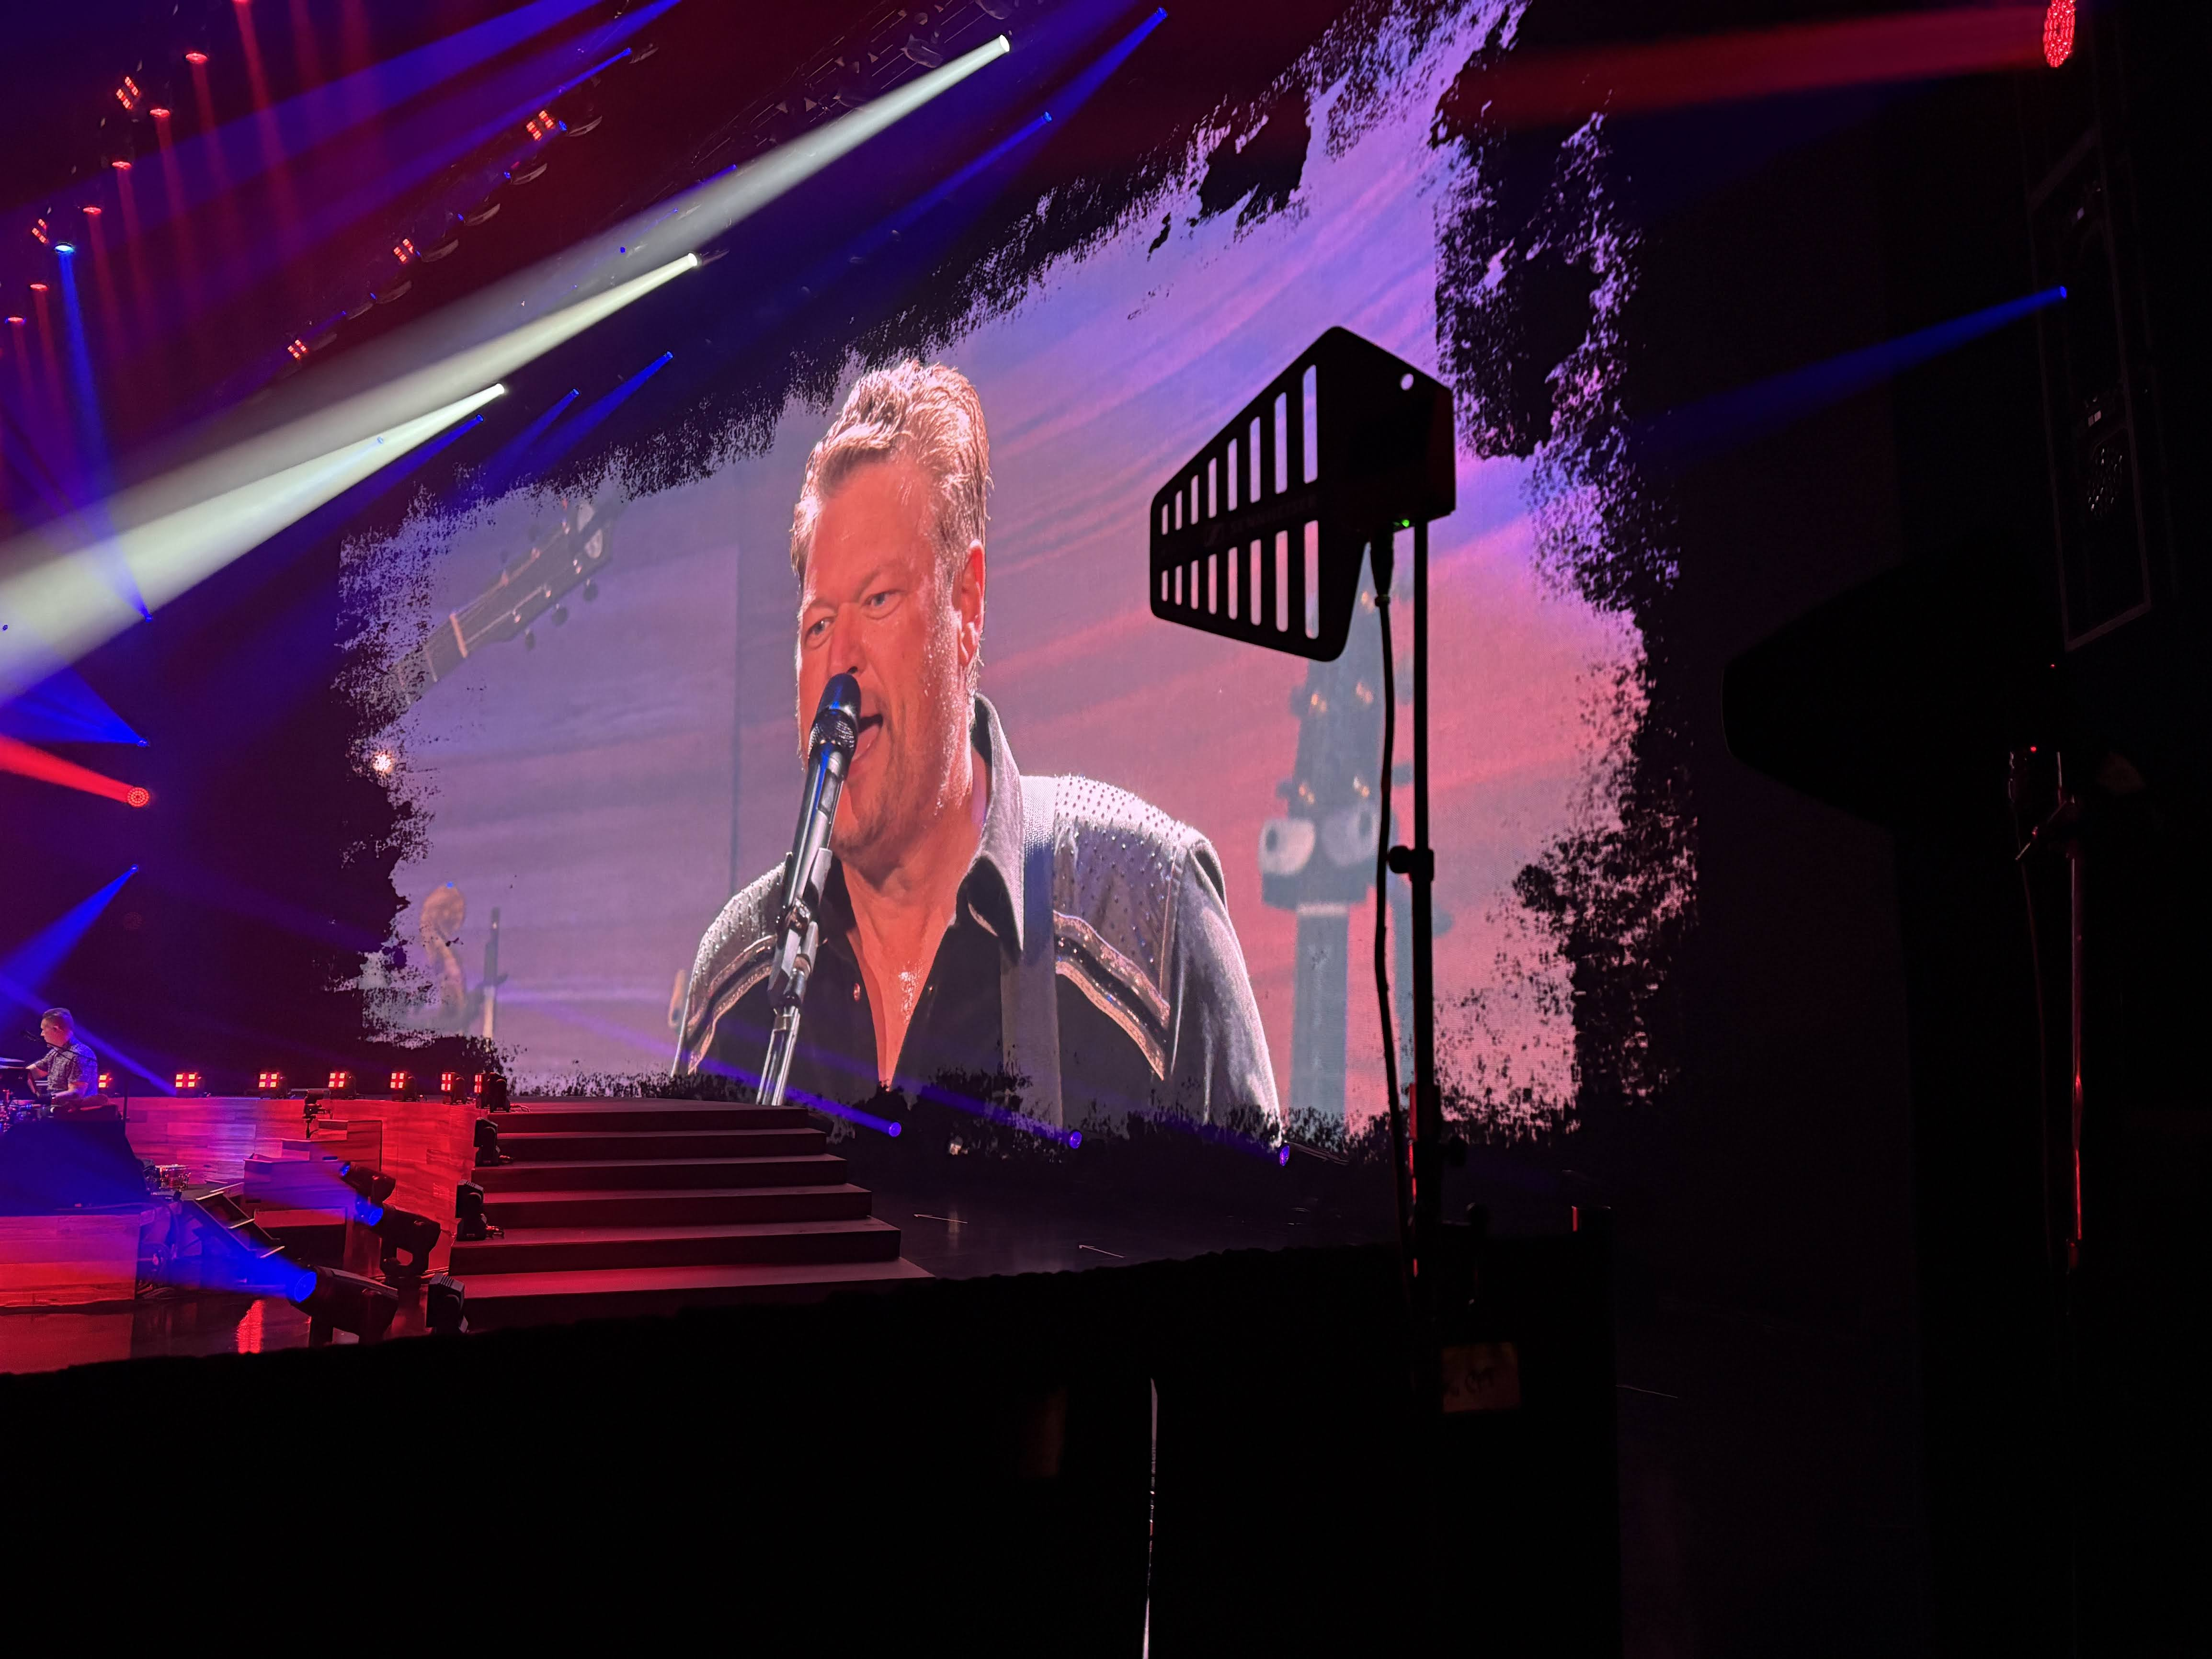

From Las Vegas’ Biggest Stages, Zac Brown Band and Blake Shelton Signal the Future of Wireless Audio

Production teams integrate Sennheiser Spectera to support large-scale residencies with flexible, high-density wireless performance

LAS VEGAS – March 19, 2026 – As the live entertainment landscape evolves toward increasingly complex visual and sonic spectacles, Sennheiser’s Spectera — the world’s first wideband bidirectional wireless system — has emerged as the definitive solution for the industry’s most demanding environments. Recently, two of country music’s premier acts, Blake Shelton and Zac Brown Band, successfully integrated Spectera into their high-profile Las Vegas residencies at Caesar’s Palace and Sphere respectively, proving that the future of wireless audio has arrived.
The challenge of a Las Vegas residency lies in the sheer density of the RF environment. In a city where every square inch of the spectrum is contested, and venues like Sphere introduce unprecedented layers of electronic complexity, traditional narrowband systems are often pushed to their limits. For Andy Hill, the veteran monitor manager for Zac Brown Band, the move to Spectera was a strategic necessity to reclaim "breathing room" in a crowded airwave landscape. By consolidating all in-ear monitor mixes into just two RF channels, the production was able to maintain a massive channel density while leaving ample space for other critical narrowband wireless needs.

"We have been trying to get as many mixes as we can in as small of an RF space as possible," said Hill. "With Spectera, we fit everything — all of the in-ears — within just two RF channels. That let us have a lot more space for all the narrowband RF coordination required for a show of this scale."
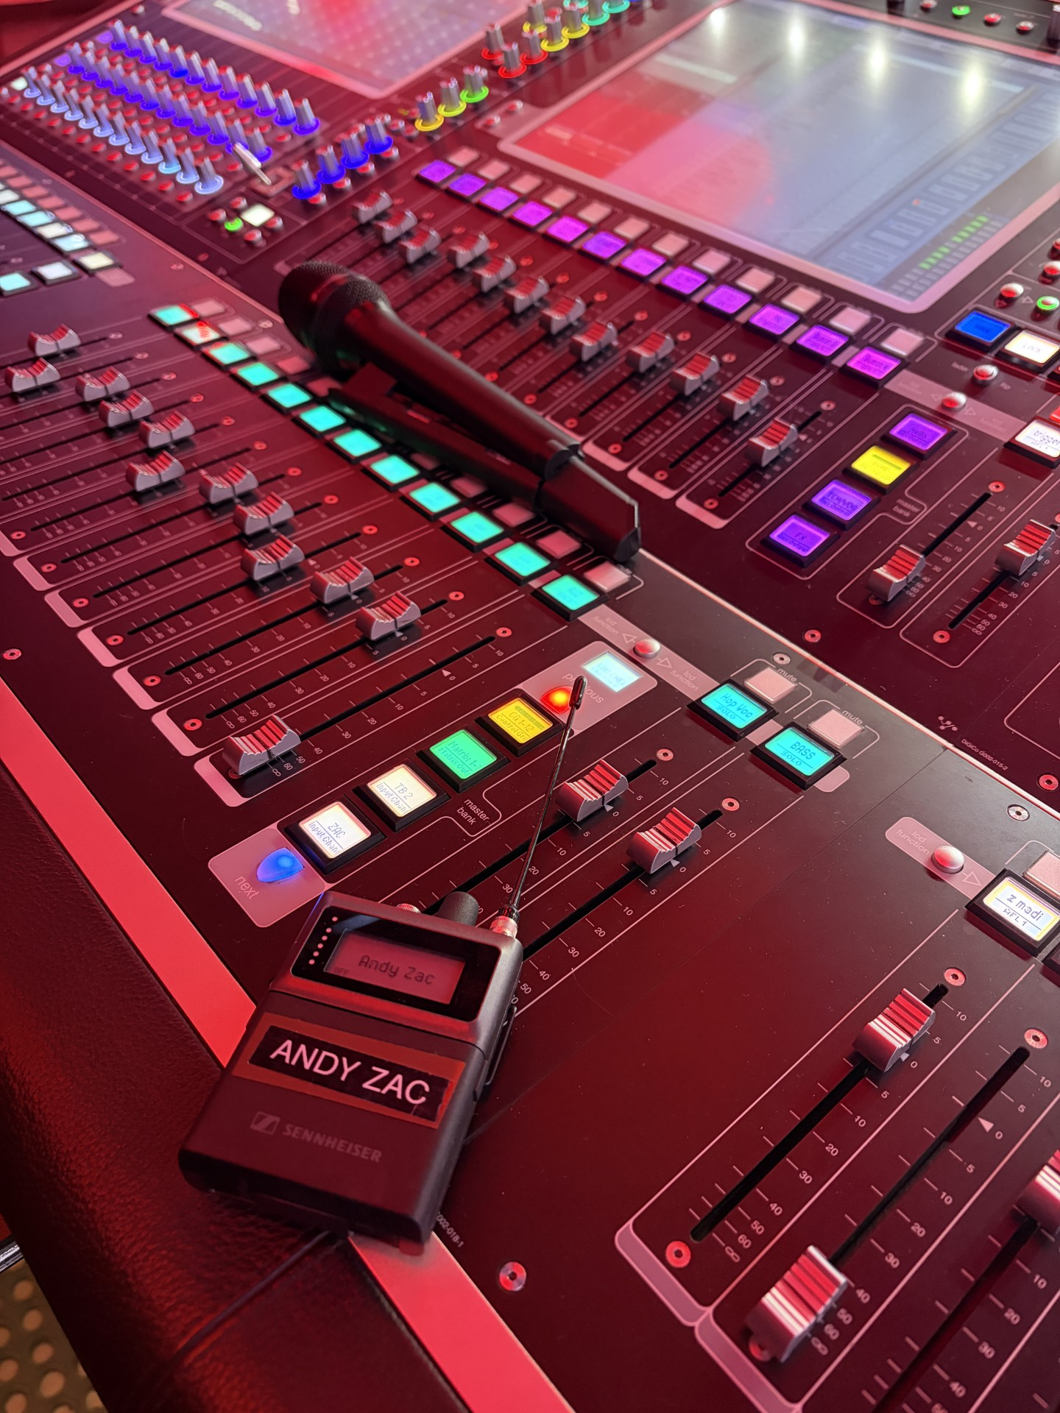
Zac Brown Band monitor manager Andy Hill says Spectera allowed the band to reclaim "breathing room" in a crowded RF landscape.

Safety and reliability are the cornerstones of any world-class production, and the Spectera system has quickly moved from a "new technology" curiosity to a trusted workhorse. Brad Baisley, monitor engineer for Blake Shelton’s residency at Caesar’s Palace, oversaw the deployment of the system during an intensive run where consistency was paramount. After months of testing and live use, the consensus among the engineering teams is one of absolute confidence.

"I've been in Nashville since the late 90s and have seen significant change in how we handle audio. Progress like this is unheard of,” said Brad Baisley. "The installation worked perfectly in Vegas recently for the residency at Caesar’s Palace with Blake Shelton. There were no sound issues, no technical issues, just happy performers and happy audience members.”

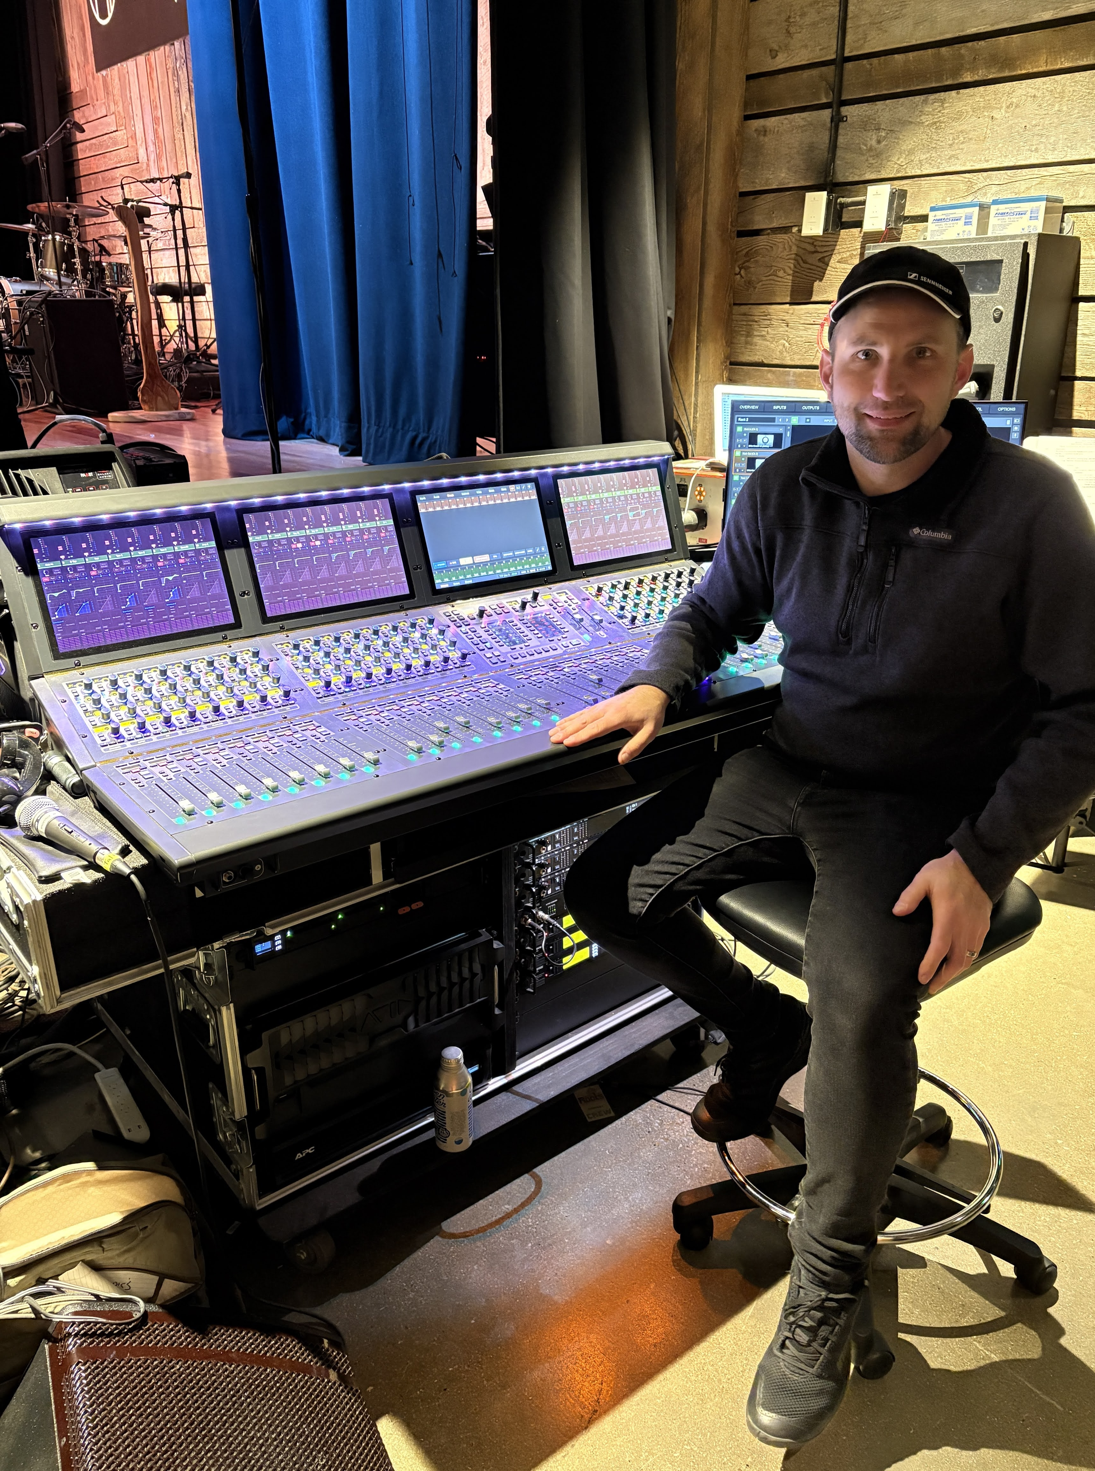
Brad Baisley, monitor engineer for Blake Shelton.

The physical infrastructure of these residencies also saw a significant transformation thanks to Spectera’s streamlined design. By replacing heavy, bulky BNC cables with standard Cat 5 cabling, the system has simplified the logistical burden of the load-in and installation process. At Sphere, Andy Hill and his team utilized a sophisticated multi-antenna network to ensure total coverage, placing antennas on either side of the stage and even behind the massive video walls to maintain connectivity during the band's quick-change sequences.

"The RF performance is generally much better because there are no whisps and pops, which can be annoying to most performers," Hill noted regarding the switch from traditional setups. "It’s substantially faster to deploy on a daily basis once the system is set up — and being able to see if people’s belt packs are on and connected from the software is incredibly handy at the beginning of a show."
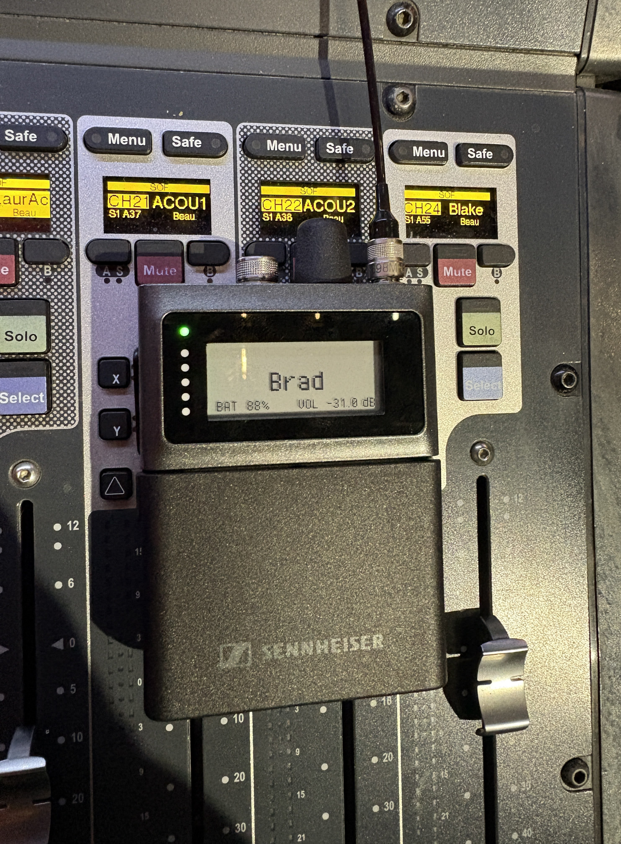
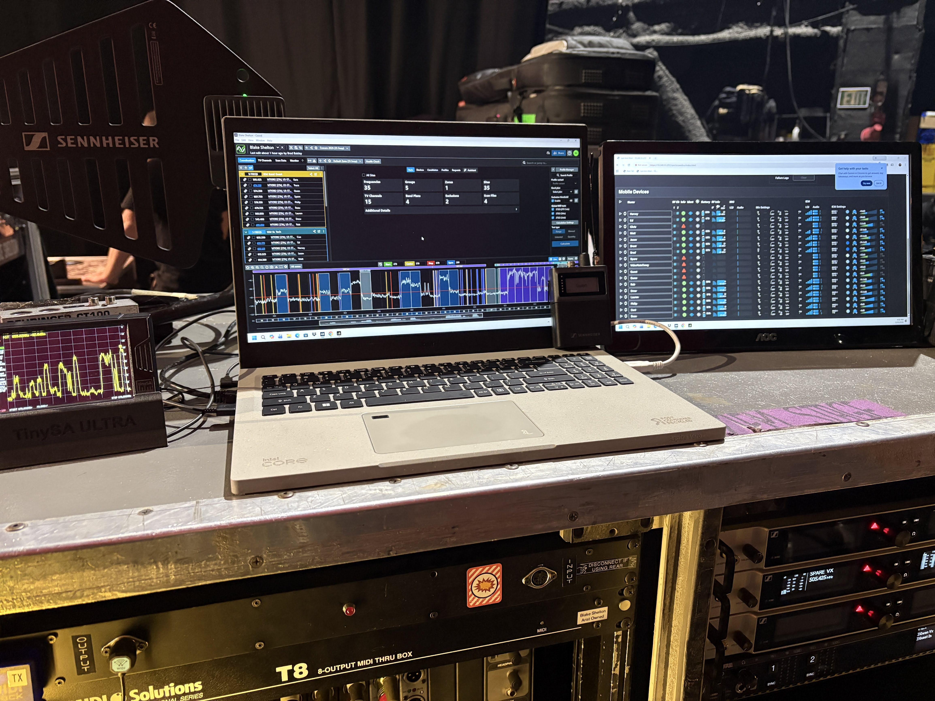
Spectera allowed Baisley and the rest of the crew on Blake Shelton’s Las Vegas residency to streamline wireless microphones and in-ear monitoring within a single wideband RF ecosystem. Photo credit: Brad Baisley

Reflecting on the successful integration of the new technology into a high-pressure environment, both artists’ engineering teams highlighted how the system manages to simplify the complex. By providing a stable, high-fidelity audio link that resists the interference common in major metropolitan areas, Spectera allows the technical crew to focus on the nuances of the mix rather than the limitations of the hardware.


Blake Shelton performs on stage at Caesar’s Palace with the support of Spectera, facilitating clear, reliable wireless audio for both performers and production. Photo credit: Jamie Wendt.

"We just finished up the residency, and we all want to shout from the rooftops how smooth it went due to Spectera," Baisley added. "It's about making sure the artist has exactly what they need to perform at their best, and this system delivered that throughout our entire time at Caesar's."

Ultimately, the success of these residencies marks a pivotal moment for live sound technology. As two of the first major productions to commit to and deploy Spectera on this scale, Zac Brown Band and Blake Shelton teams have paved the way for other engineers to embrace wideband technology.


Spectera’s wideband wireless systems supports Zac Brown Band on stage, providing the production team with efficient RF coordination and dependable monitoring during their residency.

As Sennheiser continues to refine the Spectera ecosystem based on real-world feedback from these elite engineers, the system is poised to become the backbone of the next generation of global concert tours and residencies. In a city where the house usually wins, Sennheiser Spectera has tipped the scales back in favor of the artists. By cutting through the digital noise of the Las Vegas Strip with the soul of Nashville, Zac Brown Band and Blake Shelton prove that Spectera isn't just a new piece of gear — it’s the new standard for the world's most iconic stages.

###

About the Sennheiser Brand – Over 80 Years of Building the Future of Audio
Building the future of audio and creating unique sound experiences for our customers - this is the aspiration that unites the employees of the Sennheiser Group worldwide. The independent, family-owned company Sennheiser was founded in 1945. Today, it is managed in the third generation by Dr. Andreas Sennheiser and is one of the leading manufacturers in the field of professional audio technology.

sennheiser.com | neumann.com | merging.com

Local Press Contacts:
Daniella Kohan
daniella.kohan@sennheiser.com
+1 (860) 227-2235

InGear
Chloe Hildeman
chloe@ingearpr.com
+1 425-466-2264

